**ACCIDENT LOCATIONS ON INDIAN ROADS** *(5th July 2023)*

Lokeshwaran.S

Naveen.B

Keerthana.R

AI & DS

Rajalakshmi Institute of technology, kuthambakkam, Chennai.

AI & DS

Rajalakshmi Institute of technology, kuthambakkam, Chennai.

AI & DS

Rajalakshmi Institute of technology, kuthambakkam,Chennai.

Mail id:  [lokeshwaran.s.2021.ad@ritchennai.edu.in Naveen.b.2021.ad@ritchennai.edu.in](mailto:%20lokeshwaran.s.2021.ad@ritchennai.edu.in%20%20%20%20%20%20%20%20%20Naveen.b.2021.ad@ritchennai.edu.in)

keerthana.r.2021.ad@ritchennai.edu.in

**ABSTRACT**

The spatial distribution of accident locations in India is investigated in this study using Geographic Information System (GIS) software and data from the Ministry of Road Transport and Highways. The most recent accident statistics, which includes data through 2021, are used in the analysis. In order to conduct the research, detailed accident data from MoRTH must be obtained. This data contains details such accident type, severity, time of occurrence, and geographic locations. GIS software uses these coordinates to create visual representations and do spatial analysis. This study examines accident locations, patterns, and hotspot areas across India in order to provide useful insights into the spatial distribution of road accidents. It makes an effort to pinpoint high-risk areas, substantial accident-prone areas, and key national causes of traffic accidents. The results of this study may be used to design effective strategies for reducing accidents and improving road safety by policymakers, law enforcement personnel, and urban planners. By locating areas with a high accident prevalence, targeted actions can be carried out to lower accidents, reduce injuries, and enhance overall road safety.

Keywords: accident locations, India, MoRTH, GIS software, spatial distribution, hotspot areas, road safety, accident prevention.

**INTRODUCTION**

**I** India, the second-most populous country in the world, is well known for its diverse landscapes and bustling urban areas. However, India still needs to do a lot of work to increase traffic safety and prevent accidents. In India, traffic accidents are now a serious public health concern due to the significant number of deaths, injuries, and monetary losses they produce.

**II** The objective of this study article is to provide a concise overview of accident sites in India while shedding light on the geographic distribution and primary causes of accidents. By studying the accident data and identifying the high-risk areas, policymakers, urban planners, and transportation authorities can get valuable insights to execute targeted interventions and enhance road safety measures. The study looks at a number of factors associated to accident sites, such as the differences between urban and rural areas, the types of roads, and how much traffic congestion affects accident frequency.

**III** In this essay, the various reasons of accidents in India are discussed, including driver irresponsibility, inadequate infrastructure, slack enforcement, and the influence of the weather. To create effective strategies and policies to decrease accidents' frequency and severity, it is crucial to understand the underlying causes of accidents..

**IV** The findings of this study will contribute to the body of information already accessible on road safety in India and operate as a helpful resource for scholars, decision-makers, and practitioners in the field. By obtaining a detailed understanding of accident locations and their contributing factors, stakeholders can work together to improve transportation networks, safer driving conditions, and ultimately save lives.

**V** The overarching purpose of this study is to highlight the significance of accident scenes in India and the urgent need for solutions that are based on facts to address the country's growing road safety problems. India may strive to increase traffic safety and protect the wellbeing of its citizens by addressing the root causes and taking preventative measures.

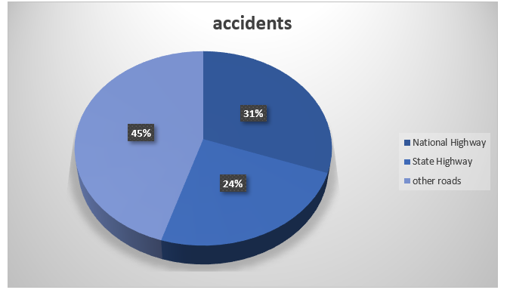

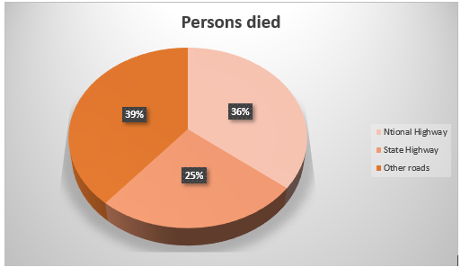

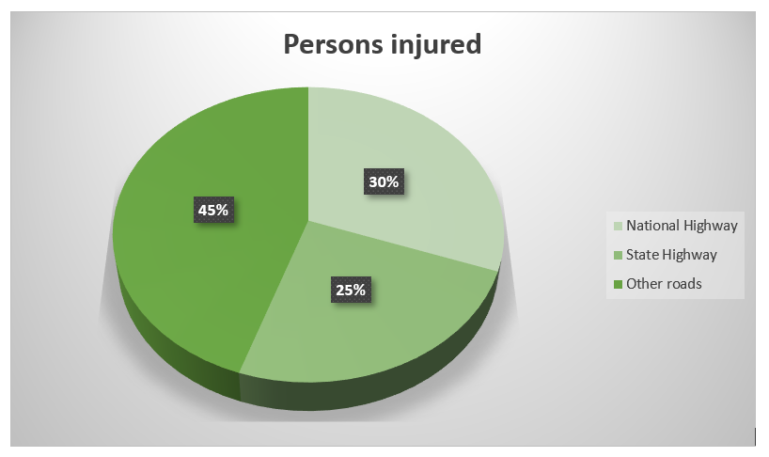

**LITERACY SURVEY**

The survey was conducted in 2019, according to this assessment of literacy. About 4,49,002 incidents occur over 62,15,797 kilometres, and 4,51,361 people die in accidents. The impact on accidents involving persons was significant as a result. Accidents are the human community's leading source of misery, according to this survey table.

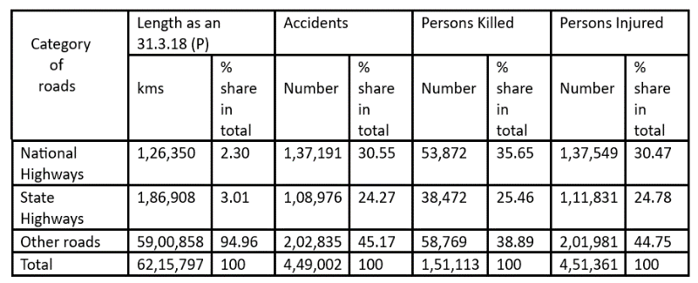

**OBJECTIVE**

The sites of accidents in India must be identified and studied in order to implement targeted actions and strategies to reduce casualties, increase road safety, and prevent accidents.

**OUTCOMES**

It's important to keep in mind that different Indian regions may have very different road safety laws and accident statistics.

**I** Reduction in deaths: Less fatalities on the roads may result from accident locations that are optimised. There are many ways to accomplish this, including better infrastructure, better traffic management, more enforcement of traffic laws, and public awareness campaigns. By locating accident-prone areas and implementing focused interventions, the severity of accidents and the number of fatalities that result can be reduced.

**II** By addressing accident-prone regions, it is possible to reduce the number and severity of injuries sustained in traffic accidents. By implementing safety measures including speed limit enforcement, crash barriers, improved lighting, and pedestrian-friendly infrastructure, injury risks can be lowered.

**III** Finding areas that are prone to congestion and making improvements there are necessary for improving traffic flow. Examples of these include suitable road markings, traffic signal optimisation, intelligent transportation systems, and dedicated lanes for public transportation. By improving traffic management and reducing traffic congestion, accident risk can be reduced.

**IV** Improved emergency response: Locating accident hotspots can help with the more effective use of emergency response resources. By strategically positioning ambulance services, establishing reachable helplines, and improving communication infrastructure, the response time to accidents can be shortened. This might be able to save lives by offering the injured folks urgent medical attention.

**V** Cost savings: Accident locations can be improved for financial gain. The strain on healthcare systems can be lessened by lowering the incidence of accidents and the resulting injuries. Additionally, fewer accidents mean fewer claims, insurance payouts, and legal expenses, which could translate into savings for both individuals and society at large.

**VI** It's important to keep in mind that achieving these goals necessitates a comprehensive approach that involves citizen involvement, government action, and ongoing monitoring and assessment. The specific outcomes of optimising accident locations in India would depend on the effectiveness and application of these techniques in each region.

**CHALLENGES**

India's accident sites encounter a variety of difficulties that can be linked to a number of variables. The following are some of the main issues with accident sites in India:

**I** Poor Infrastructure: India has a large number of accident-prone areas that are plagued by poor infrastructure, including poorly designed roads, a lack of signage, poor lighting, and inadequate pedestrian facilities. These elements raise the risk of accidents.

**II** Traffic Congestion: Urban regions with heavy traffic generally have chaotic road conditions, which raises the risk of accidents, and accident-prone places are made even worse by irresponsible driving and overloaded roads.

**III** Insufficient Enforcement of Traffic Laws: Although there are traffic laws and regulations in India, they are difficult to enforce. When breaches go unnoticed, dangerous behaviour can continue because of a lack of police presence and ineffective monitoring mechanisms.

**IV** Lack of Awareness and Education: The lack of knowledge among road users on safe driving behaviours, pedestrian safety, and observance of traffic laws presents a serious difficulty. Accidents are more likely to occur at particular sites when there is insufficient education and awareness raising.

**V** Poor Road Safety Culture: To reduce accidents, it is crucial to promote road safety culture. However, there is a lack of understanding about the value of road safety and responsible driving in many areas of India, which contributes to a greater rate of accidents.

**VI** Inadequate Emergency Response: Rapid emergency reaction is essential for reducing the effects of accidents. However, in some accident sites, there can be limited access to emergency services, including ambulances and hospitals, which might cause delays in giving the injured medical care.

**VII** Encroachment and Pedestrian Safety: In numerous places, encroachments on pathways and designated pedestrian areas require people to cross roads, making them more susceptible to accidents. For accident-prone areas to become safer, suitable pedestrian infrastructure must be provided, and encroachments must be discouraged.

**VIII** A comprehensive strategy is needed to address these issues, including better infrastructure development, more traffic law enforcement, public awareness programmes, stronger emergency response systems, and a focus on fostering a road safety culture.

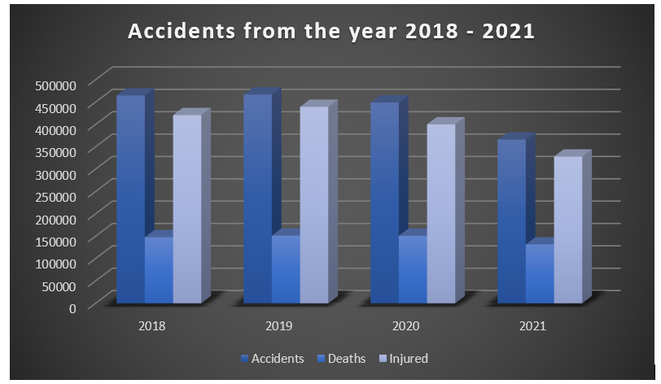

***Graphical data from 2018–2021.***

**ARCHITECTURE/SYSTEM MODEL**

This project's architecture uses a variety of third-party data and tools. The MoRTH accident data must be imported in order to start gathering data from MoRTH. Process the data after that to see where the accidents happened. On the other side, look for clusters in the accident data. Make adjustments or use handling tools if there are clusters to get around them.

The next step is to locate the accident-prone areas and determine if there are high-frequency road segments or not. The conclusions regarding the error indicated earlier are presented after that. Then mention the interventions and the contributing circumstances.

When everything is finished, make sure to point out the significance of data-driven road safety measures as well as the necessity of coordinated efforts and stakeholder participation. This completes the process of creating the model.

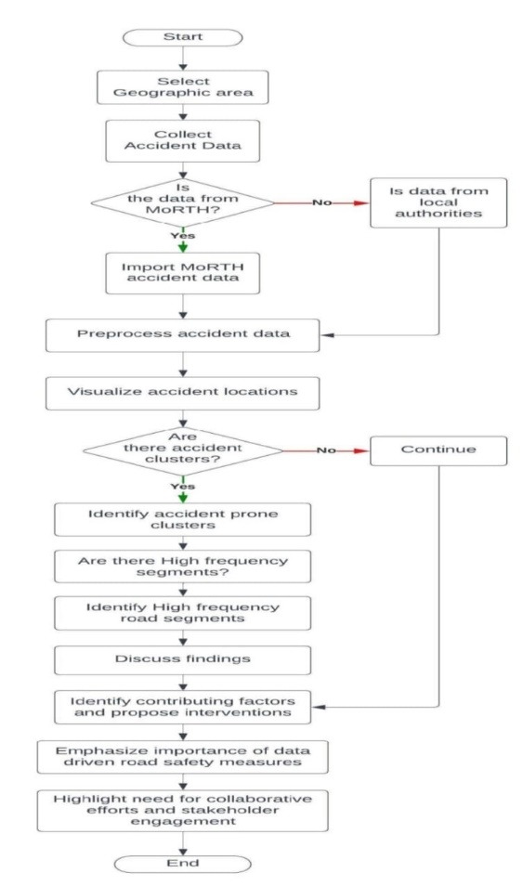

**SOFTWARE MODEL FOR IMPLEMENTATION**

QGIS is a valuable tool for mapping blackspots on a map, which are locations with a high incidence of accidents or other safety concerns. Here's how QGIS assist us in mapping blackspots:

Data Import: QGIS allows us to import relevant data sets into the software. This can include accident data, road network data, traffic flow data, and other relevant geospatial information.

Spatial Analysis: QGIS provides a wide range of spatial analysis tools to identify and analyse blackspots. For example, we can use overlay analysis techniques to identify areas where accidents frequently occur in relation to road networks, intersections, or specific geographic features.

Hotspot Analysis: QGIS offers tools for hotspot analysis, which helps identify statistically significant clusters of accidents. These tools can help pinpoint areas with an unusually high density of accidents, indicating potential blackspots.

Visualization: QGIS allows to create visual representations of blackspots on a map. We can symbolize the identified blackspots using distinctive colours or symbols to highlight their locations. This visualization can help in effectively communicating the distribution and severity of blackspots.

Spatial Querying: QGIS enables us to perform spatial queries to extract specific information about blackspots. For example, we can query the accident data to retrieve details such as the number of accidents, types of accidents, or severity within a particular blackspot area.

Map Composition: QGIS provides tools for designing and composing maps. It can create visually appealing maps that combine the blackspot locations with additional contextual information such as road infrastructure, traffic patterns, or relevant demographic data. This helps provide a comprehensive view of the blackspots and their surroundings.

By utilizing these capabilities of QGIS, we can identify, analyse, and visualize blackspots effectively.

**I** GIS software was utilised to create the model. Geographic Information System (GIS) is the abbreviation for the GIS. A computer system called a GIS is used to collect, store, verify, and display information about positions on the surface of the Earth. GIS can assist people and organisations in better understanding geographical patterns and relationships by connecting seemingly unconnected data.

**II** The White House defines spatial data infrastructure as "the technology, policies, standards, human resources, and related activities necessary to acquire, process, distribute, use, maintain, and preserve spatial data." GIS technology is an essential component of this infrastructure. Any information that involves a location can be used by GIS. Latitude and longitude, address, and ZIP codes are only a few examples of how to provide the location.

**III** We can compare the positions of multiple items to establish their links using GIS technology. Using GIS, for instance, a single map might display areas that pollute and areas that are sensitive to pollution, such as wetlands and rivers, as well as areas that create pollution, such as industrial areas. A map like this one might be used to pinpoint the regions where water supplies are most in danger.

**IV** GIS Maps: Depending on which data layers are included, once all the needed data have been recorded into a GIS system, they can be merged to create a wide range of unique maps.

**V** Comparing natural features with human activities is one of the most frequent uses of GIS technology. For instance, GIS maps can show which man-made structures are close to particular natural structures, such as which residences and businesses are in flood-prone zones. Users of GIS technology can "dig deep" into a particular location using a variety of information. Maps of a single area or city can be used to correlate data such as median income, book sales, or voting trends. The same map can have any GIS data layer added or removed. Information about numbers and density can be displayed using GIS maps. The number of doctors in a neighbourhood in relation to the local population, for instance, can be displayed using GIS.

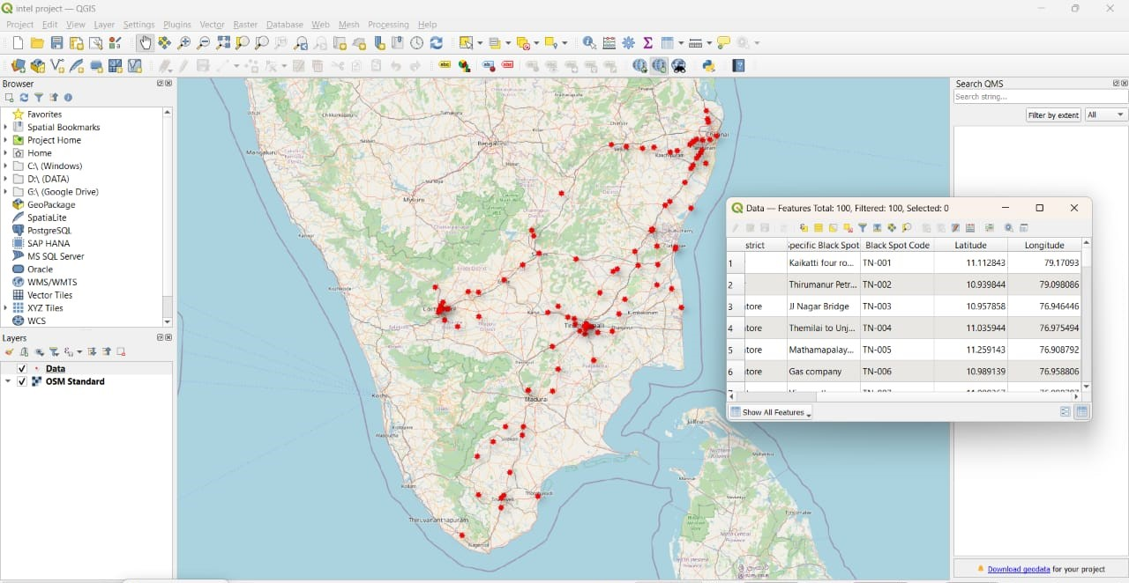

***Plotting of blackspots using the MoRTH and GIS Software***

**CONCLUSION**

In conclusion, India has experienced countless mishaps in a variety of places recently. Roads, railroads, waterways, as well as industrial and residential locations have all seen these catastrophes happen. Depending on factors like population density, infrastructure, and human error, some places have a higher number of accidents and accidents of varying severity. To lower the frequency and severity of accidents, it is crucial for authorities to concentrate on enhancing safety precautions, upholding laws, and putting better infrastructure in place. Campaigns for public awareness and instruction on general and vehicular safety can also help prevent accidents and lessen their effects.

addressing the issue of accidents in India and ensuring the welfare and safety of its population requires a concerted effort from all parties. Then, using the MoRTH data and GIS tools, we drew the accident locations on Indian highways. The accident sites in India that were identified using GIS software are those that are highlighted in red.

**REFERENCES**

*Gholam Ali Shafabakhsh, Afshin Famili, Mohammad Sadegh Bahadori., 2017. GIS – based spatial analysis of urban traffic accidents.*

*Romi Satria, Maria Castro., 2016. GIS tools for analysing accidents and road design.*

*Deepthijayan, K., Ganeshkumar, B., 2010. Identification of accident hotspots: a GIS based implementation.*

*Flauhaut, B., Mouchart, M., Martin, E.S., 2003. The local spatial autocorrelation and the kernel method for identifying black zones: a comparative approach. Accident analysis & prevention.*

*Prasannakumar, V., Vijith, H., Charutha, r., 2011. Spatio-temporal clustering of road accidents: GIS based analysis & assessment.*

*Budiharto,U., Saido, A.P., 2012. Traffic accident blackspot identification and ambulance fastest route mobilization process for the cities.*

*Chen, H., 2012. Blackspot determination of accident locations & its spatial analysis based on GIS.*